Title or Task: | Create a slide show in Flash  

Description:

Files Required
Suitable for Classes: | AIT • Multimedia • Cert II IT • Cert II Bus
Area: | Technology & Enterprise
Teacher: | Mr Peter Faulks

Timeline

Date Due:

Task Brief:

Outcomes:

Items highlighted in yellow are tasks for you to complete
Items in Purple are help tips

Create a slide show in Flash
Your task is to create a simple linear web page slide show about a gizmo multimedia device such as Mobile phone, Camera, etc.

Create a slide show in Flash using at least four pictures some text and special effects

Open Flash

Open flash click on Action Script 3.0

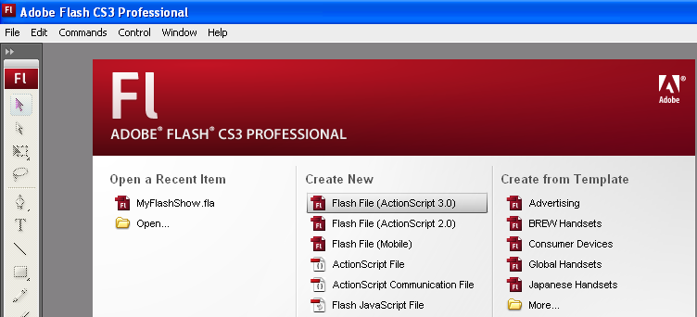

You will be shown this screen

Call this Slide Fader

In Photoshop resize a set of images these to to 660x350 pixels

I am using a set of colour images set to 660x350 pixels

Set the document size to the same size as your images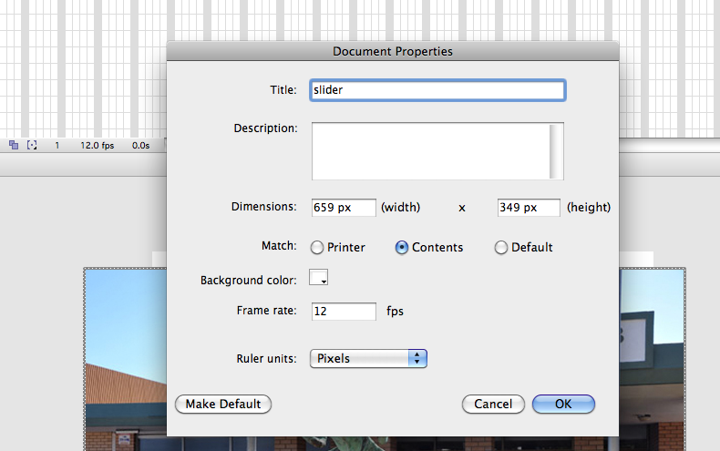

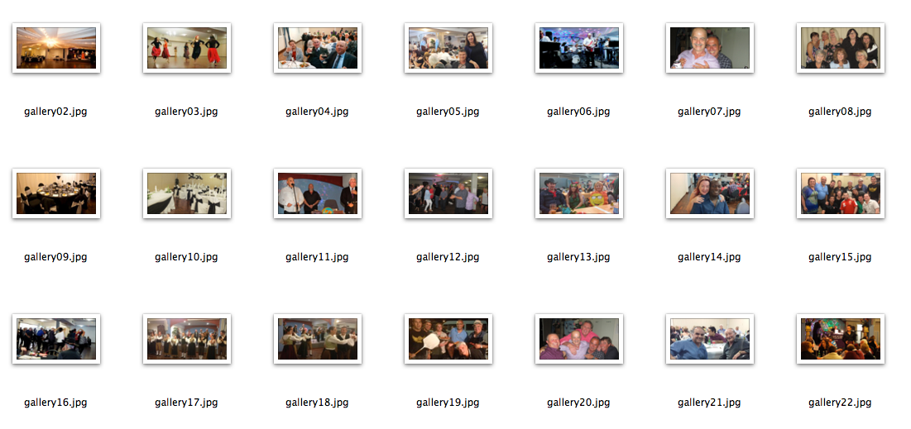

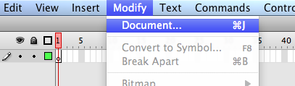

Now import all images to the Library
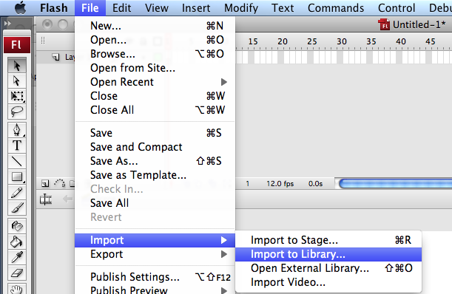

Make sufficient layers for the number of images I have 20

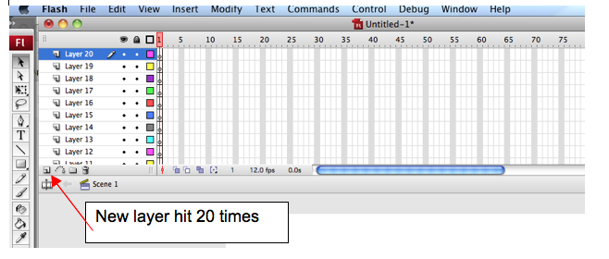

Your Flash file should look like this

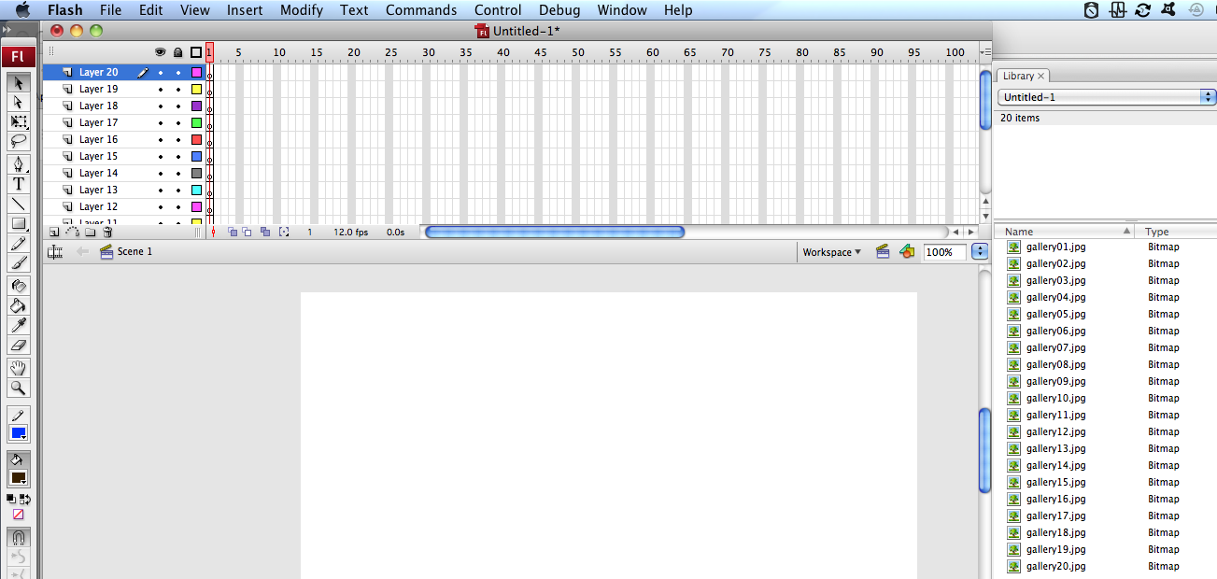
Drag the first image onto the canvas

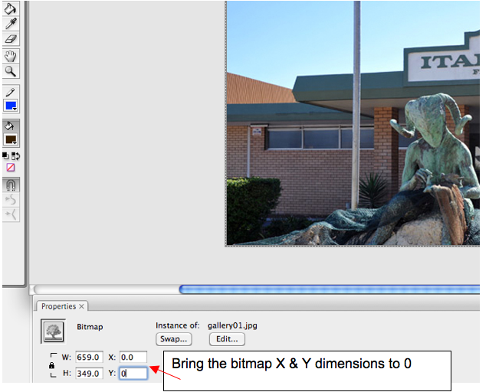

Convert the image to a Symbol
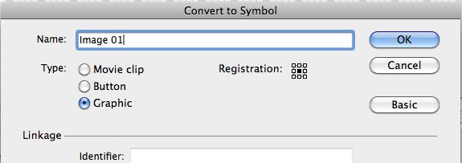
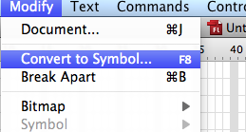

Name the layer (image 01) then click on the next layer down and bring in the next image (Turn the eye off the first image)

Then adjust the bitmap X & Y to 0 and convert this image to a symbol

Insert a keyframe at 5 for layer 1 (Image 1)

Click on photo and convert to symbol

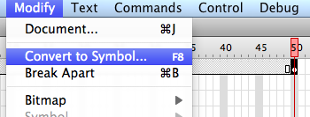

Name it and select graphic center registration
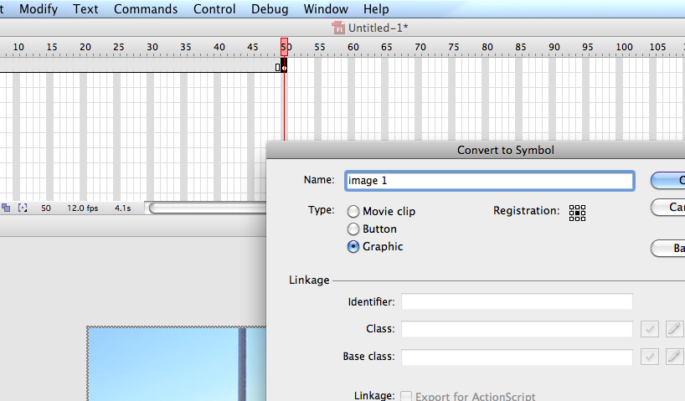

Name the next layer down image 2 and with that layer selected drag in the next image
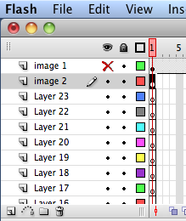

NOTE You may turn off the eye on image 1

0 zero out the x & y

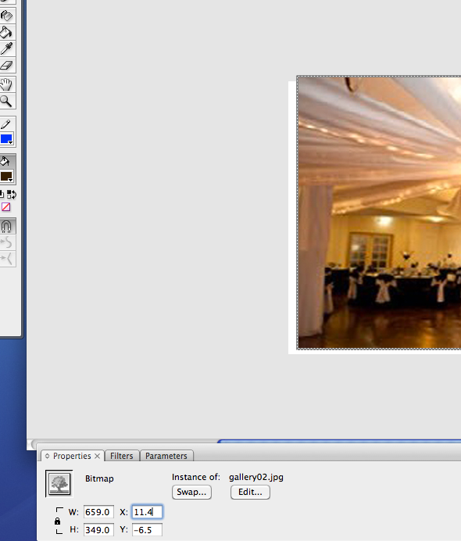

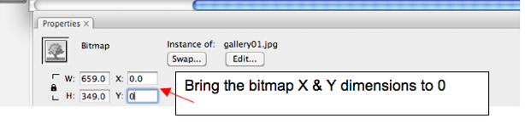
Repeat for all images

Click on the next layer and insert a key frame about half way back from layer 1

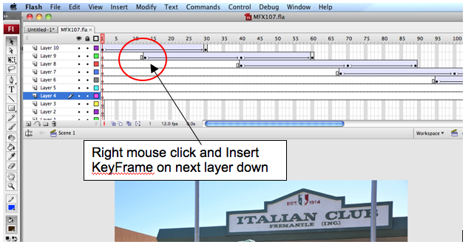

Turn off eye on layer 1 then drag in the next image

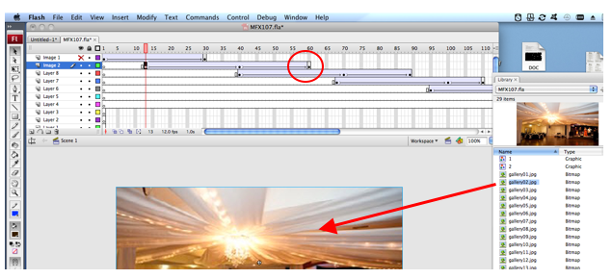

Adjust the bitmap X & Y to 0 and convert this image to a symbol

Now insert a key frame at 60 so the image remains in shot for some time.
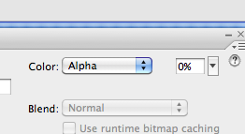
About half way along insert another key frame

Then at the end of that layer Click on the image and set Alpha to 0

The image will then fade out from the center key frame to reveal the next image which will be inserted as this one was

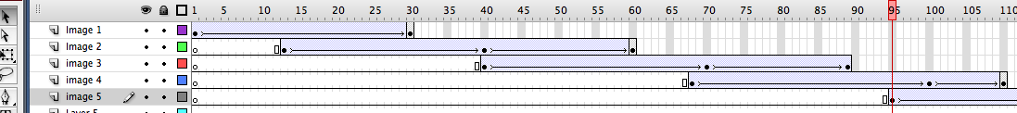

Save your work and run the movie



